**Create tables in Hive and write queries to access the data in the table**

**AIM:**

To create tables in Hive and write queries to access the data in the table.

**PROCEDURE:**

**Installation of Hive:**

1. Installing Apache Derby Install Apache Derby 10.14.2.0

[https://db.apache.org/derby/derby_downloads.html#For+Java+8+and+Higher](https://db.apache.org/derby/derby_downloads.html#For%2BJava%2B8%2Band%2BHigher)

1. Downloading Apache Hive binaries <https://downloads.apache.org/hive/hive-3.1.2/>

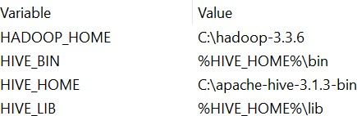

3.

Setting

environment

variables

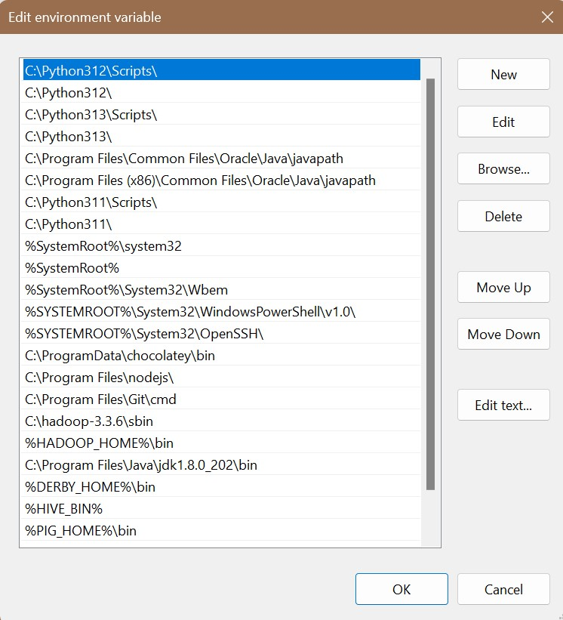

* 1. Copy Derby libraries we should go to the Derby libraries directory (db-derby-10.14.2.0\lib) and copy all *.jar files. Then, we should paste them within the Hive libraries directory.
  2. Configuring hive-site.xml and Hive’s Bin folder

Refer following link to download the file. Also download the guava file. Put hive- site.xml file to hive’s conf location and replace hive’s current guava file with this one in lib location. Also download the bin folder from link and replace the existing hive’s bin folder. <https://1drv.ms/f/s!ArSg3Xpur4Grmw0SDqW0g44T7HYU?e=wDsoBn>

1. Starting Hadoop Services

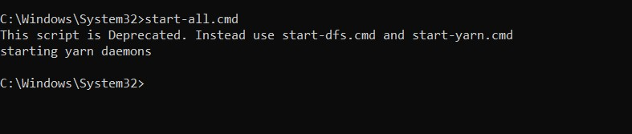

1. Derby Network Server: Run the following command in separate window to open Derby

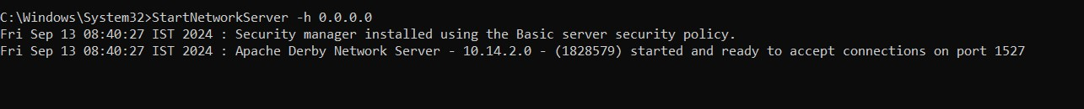

1. Starting Apache Hive

Go to Apache Hive’s bin location with cd command and run the following command:

1. Open Hive shell by typing:

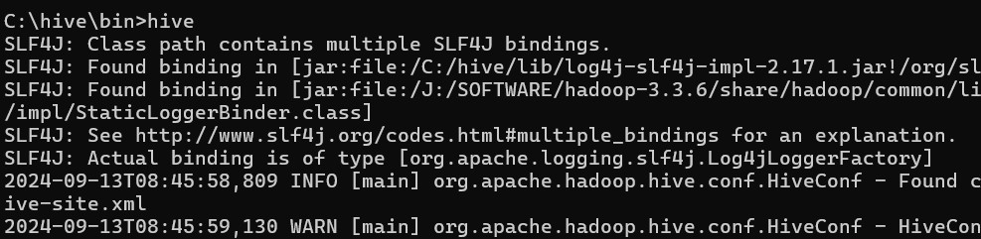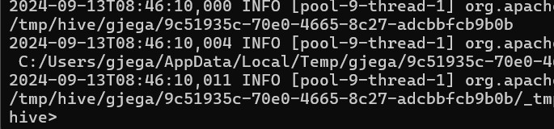

**Create a Database:**

Start by creating a database. Open the Hive CLI and follow the steps below:

1. Use the **CREATE DATABASE** statement to create a new database:

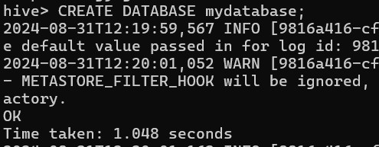

1. Verify the database is present:

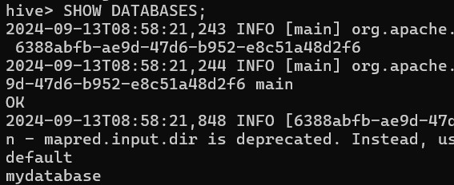

1. Switch to the new database:

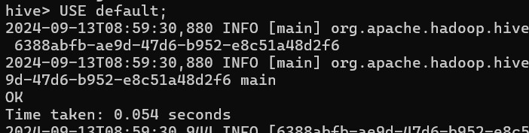

**Create a Table in Hive**

CREATE TABLE students (name STRING, roll INT, dept STRING);

**List Hive Tables and Data**

To show all tables in a selected database, use the following statement:

SHOW TABLES;

To show table column names and data types, run:

DESC students;

To display table data, use a **SELECT** statement. For example, to select everything in a table, run:

SELECT * FROM students;

**OUTPUT:**

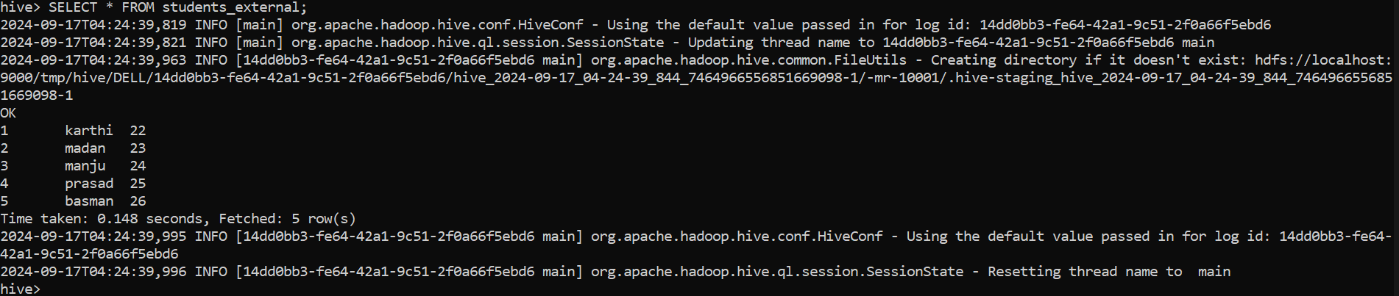

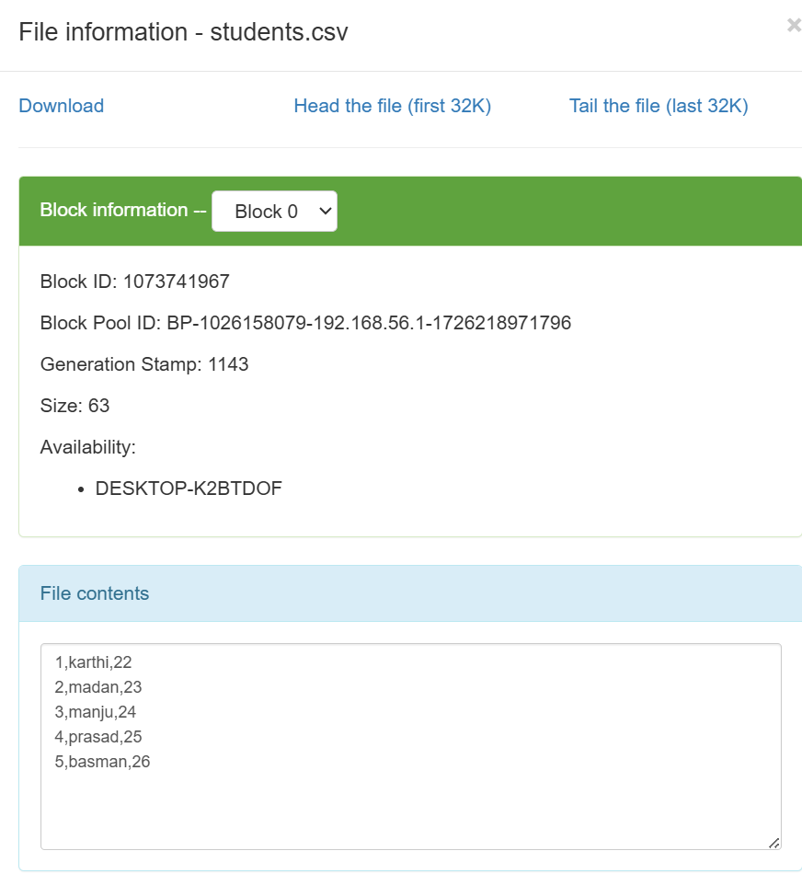

**RESULT:**

Thus to create tables in Hive and write queries to access the data in the table is completed successfully.